**How to use the File Upload feature on Riki:**

1. Go to a wiki page and choose the edit option.

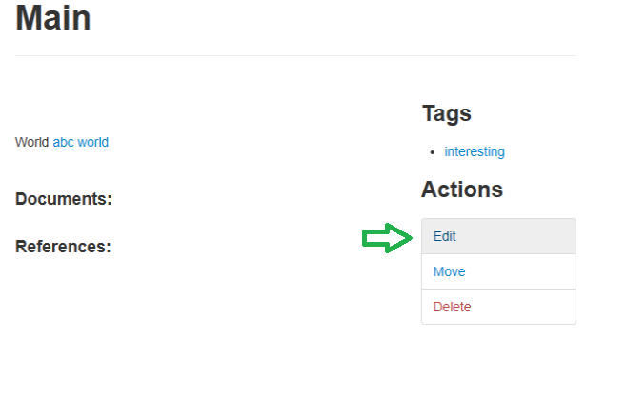

1. Scroll down to the Upload File field (you can also edit other page information at this time).



1. Browse your pc for an image, video, or document file. Accepted file types are .png, .jpg, .jpeg, .mp4, .doc, .docx, .pdf, .txt, .xls, and .xlsx.

1. Riki will save the file and add it to the page in the appropriate place. Images will be displayed at the top, videos will be displayed below images, and documents will appear as links that will open the file in a separate tab.

